n l m_{l} m_{s}
- State the four quantum numbers and the possible values they may have.

2. Name the orbitals described by the following quantum numbers
a. n = 3, l = 0 c. n = 3, l = 2
b. n = 3, l = 1 d. n = 5, l = 0
3. Give the n and l values for the following orbitals
a. 1s d. 4d
b. 3s e. 5f
c. 2p
4. Place the following orbitals in order of increasing energy:
1s, 3s, 4s, 6s, 3d, 4f, 3p, 7s, 5d, 5p
5. What are the possible m_{l} values for the following types of orbitals?
a. s c. d
b. p d. f
6. How many possible orbitals are there for n =
a. 4
b. 10
7. How many electrons can inhabit all of the n=4 orbitals?

Identify the element whose last electron would have the following four quantum numbers:

8. 3, 1, -1, +1/2___________ 11. 4, 3, +3, -1/2___________
9. 4, 2, +1, +1/2___________ 12. 2, 1, +1, -1/2___________
10. 6, 1, 0, -1/2____________
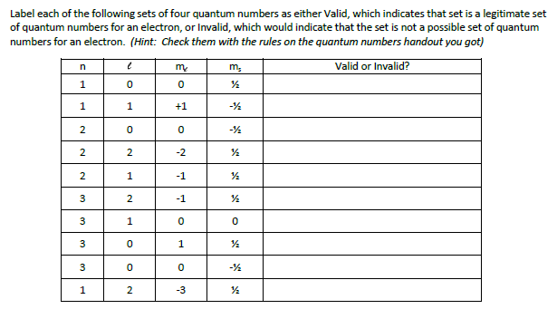
13.

Which of the following represents a permissible set of quantum numbers? (answer “yes” if permissible and “no” if no permissible)

14. 2, 2, +1, -1/2_______________ 17. 7, 0, 0, -1/2________________
15. 5, 1, 0, +1/2________________ 18. 4, 1, 8, +1/2________________
16. 6, 3,-2, +1/2_______________

Write the four quantum numbers which describe the location of the highest energy electron of the following:

19. N #7____________________ 22. Re #75______________________
20. Ni #28______________________ 23. Pu #94______________________
21. Xe #54______________________ 24. Br #35______________________

Give the four quantum numbers which describe the location of each of the following:

25. The 4th electron in carbon_____________________________________________
26. The 25th electron in Hf_______________________________________________
27. The 57th electron in Ho_______________________________________________
28. The 49th electron in Xe______________________________________________

